CYBER SECURITY AND ITS IMPORTANCE

Prachi Sukole
Faculty of Science and Technology
Bournemouth University
Bournemouth, United Kingdom
abc@mail.com
Ashlesha Jagdhane
Faculty of Science and Technology
Bournemouth University
Bournemouth, United Kingdom
def@mail.com
Manaswi Dongre
Faculty of Science and Technology
Bournemouth University
Bournemouth, United Kingdom
ghi@mail.com
Kunal Sukole
Faculty of Science and Technology
Bournemouth University
Bournemouth, United Kingdom
jkl@mail.com
Sandhya Sukole
Faculty of Science and Technology
Bournemouth University
Bournemouth, United Kingdom
mno@mail.com

Vijay Sukole
Faculty of Science and Technology
Bournemouth University
Bournemouth, United Kingdom
pqr@mail.com

Abstract—Cyber security has its unique role in securing information in every sector. Protecting information from is hackers have become more challenging. First thing that strikes in mind with the word hacker is cyber threats which is the major concern for every data handling organizations. Various policies and regulation acts were being implemented by organizations and governments to prevent cyber crimes. This paper focuses on cyber security challenges, the world is facing and required techniques and technologies to prevent them.
Keywords: cybersecurity, information security, cyber threats, cyber crimes prevention, cyber security challenges, cyber ethics, cyber crimes.

Introduction
Maintaining security over sensitive information has become the most considerable challenge. Updating and upgrading security of every internet connectable device is required to prevent data from cyber threats. The cybersecurity department not only deals with the security measures of common devices like computers, smart phone and other internet of things but also technologies like virtual machines, network topology, cloud services, servers and more. As digital forensics is also apart of this, there is a huge requirement for IT companies to analyze and investigate cyber attacks. Though there are teams like SIEM, CISSP, information security analysts are working for the companies to provide good performances, attackers coming up with different patterns to effect the CIA triad[1].

LITERATURE REVIEW
Digitization and internet in today’s world changed the human lifestyle by increasing business opportunities and social connections. On the other side, cyber criminals taking this platform as an advantage and exploiting systems to grab sensitive information. This risk of exploitation can be defended cybersecurity experts in IT sectors. The term cybersecurity came into existence in 1970s with a research project called ARPANET[2]. After observing traceable footprints along the network path using a program developed by the researcher named Bob, he started calling it CREEPER. Later Ray Tomlinson who is the creator of email service, redesigned the same program with self-replication capability. That invented first computer worm and to defend that he developed a program called REAPER. Today there are many techniques developed in cyber security to defend national and international cyber crimes. As this digital ecosystem is just a triangle of process, people and technology, the chance of being a victim is high. According to the data gathered from large scale business sectors funds has been raising with 63% in 2018 and 67% in 2019 and small scale companies with 50% in 2018 and 66% in 2019 competitively to maintain security[3]. Protecting from cyber threats, identifying threats in less time, recovering data loss, preventing system from further risk are the main functions of cybersecurity which are also considered as major concerns in companies and private lives.

IMPORTANCE
Today Internet is playing very crucial role in every days life, this makes hacker to exploit in more possible ways. Therefore, maintaining the speed of internet is as important as maintaining its security. Most of the commercial transactions, business deals, private information, human interests and emotions are processing via internet. cybersecurity is one of the fast growing tech fields, not only in IT sectors but also in health, banking, educational, military, government and public sectors as well. Even governments of every nation introducing new cybersecurity laws and policies to prevent confidentiality, integrity and availability of the data and services[4]. In every sector cybersecurity has its own importance to secure companies data. Training employees with proper knowledge and following security policies are necessary to prevent accidental insider attacks. Recruiting cyber analysts for the company’s security can help not only in identifying threat but also in incident response process. For investigating the incident and implementing countermeasures to prevent attacks, system security professionals are important.

HYPOTHESIS TESTING
There are many potential benefits with cybersecurity which supports in company’s growth, trust and reputation in the society. Implementing firewalls or access control lists can block malwares like viruses, trojans, worms and other spam or junk files and prevent systems for vulnerabilities exploitation. This results in protected systems against hacking techniques like ransomware, DDOS and more. Security techniques are helpful in preventing data loss and exposure of sensitive information. System or server crashes can be minimized and availability can be maintained[5]. Though there are considerable positive points with this, few disadvantages are also to be considered. Securing systems with centralized architectures like unified threat management systems are easy to compromise with a single point of failure. According to a proverb “don’t put all your eggs in one basket” may fail with a single point of breakdown. Establishing security architectures and security engineers are budget dependent in case of large networks. Training staff with proper cybersecurity knowledge can cause intentional insider attacks. Sometimes even firewalls can fail to identify patterns of malicious files with incorrect configuration. In case of small-scale startup companies and individual lives cyber-crimes are more frequent for financial benefits. As the company grows, resources and data increases which results in increase of network complexity. This makes a challenging task in separating network and implementing security. Following security policies without exemptions and implementing security matrices with scalability is also a problem to consider.

CYBER CRIMES
The term cybercrime is defined as any illegal activity performed used computer or internet. The definition is extended to network intrusion, disseminating malicious files into systems, bullying and thefts including hardware storage device and identity thefts. Data privacy and security will be top concern for every company or organization as most of the sensitive information is always represented in digital format. Not only in companies information but also accessing everyday communication through social websites using hacking techniques like eve dropping or social engineering can ultimately lead to emotional cheating and scams. Gaining personal information for financial gain is the most frequent happening cyber scam. According to the cyber999 report Malaysia cybersecurity cases raised 82.5% [6]. Not only on computer or server threats there will be considerable number of attacks occurring on android phones as well. As smart phones and IoT devices are linked with other existing IoT devices, accessing any week secured device led to complete network compromise. As the technology and internet convincing people with its convenient and fast methods of processing a task, companies and customers have no choice to refuse the computerized environment. According to the security report by PwC 2015, comparing 2009 to 2015, cyber-attacks in 2015 count raised to 66% [7]. Risk over sensitive information increasing rapidly and confidentiality is compromising.
Considering an example of most notorious cyber-attack raised in the UK, WannaCry ransomware attack 2017. The WannaCry outbreak which started on May 12th 2017 infected around 200,000 systems in the entire world around 150 countries costing net worth of £6 billion pounds. The attacker sent a malicious mail which automatically downloads and runs in the system when the mail is opened. This locks the computer and confidential data in it. Then attacker demand ransom in the form of cryptocurrency. In UK, this affected on national health service demanding £230 to unlock the computer and this resulted in cancellation of around 19,000 medical appointments, operations and emergency patient services[8][9].

CYBER SECURITY
As the technology is growing rapidly, there is no limits for cyber threats and no scope of slowing down. Even after following security rules and policies, companies are suffering from threat actors performing cyber-crimes like insider threats, storage devices thief, social engineering. cyber threats are not only limited to companies and individual lives but also extended to power plants and other utility services resulting in cyber war between nations. Cyber criminals are now focusing on financial benefits world wide. WannaCry and NotPetya ransomware attacks are the suitable examples of global cyber threats. Skimming technique in individual bank accounts and bitcoin mining are the recent approaches resulting in massive financial scam. These impact in financial loss as well as trust in the banks sectors and govern
ment. In the context of IT industries, Companies are more focused on financial and global growth and less concerned with the security. Providing advanced technology system for the company’s security is as important as implementing it with proper configurations for a protected environment[10]. Smart ways of securing a company is by identifying and stopping threats in the initial stage and defining own security policies for safeguarding data. This can be done by cyber specialists. In every sector, malware are the most common threats seen in computers and networks which includes computer virus, worms, trojans, adware, spam, ransomware and more. These are intended to harm computers either intentionally or accidentally. As malware programs can be developed with different patterns to cross firewalls, adopting technologies like machine learning techniques to secure websites and spam filters like intrusion detection and intrusion prevention systems are useful for identifying and blocking suspected files. As long as the security design and operations are related to the organization’s business model, confidentiality and integrity can’t be disturbed.
For maintaining standards and managing structure in an organization, PPT framework is the fundamental component. This framework is the structure of people, process and technology which is also helpful in incident response. Considering an example, DDOS attack in the company’s server is identified resulting in service unavailability. The action can be divided as the person who performed the crime, the technique he used and the equipment he used. With the three components, the framework is also called 3 pillars of cybersecurity[11].
Types of Cyber Attacks | 2012 | 2013
Viruses, worms, trojans | 100% | 100%
Malware | 95% | 97%
Botnets | 71% | 73%
Web based attacks | 64% | 63%
Stolen Devices | 46% | 50%

CYBER SECURITY IMPLEMENTATION
Buying smart high tech gadgets to secure the system or an organization is successful only when the technology is implemented properly with required configurations. Such of the most popular technologies reflecting impact on cybersecurity are presented below.

Web servers:
As internet is dealing most of the everyday things, companies started developing web based application to make it more convenient. Attacks are also increasing on the web in the same way to expose or to steal sensitive data. Cyber criminals are using web as a open platform to spread malicious files via weak secured web servers. So, securing web securing and application turned into a major concern. Using virtual private network build-in browsers can prevent cyber attacks [12].

Mobile networks:
Though people using laptops and desktops, mobile technology is dominating the internet world. Unless in companies or organizations, people are are more habitual in using smart phones and tables in which security is a concern. In individual life, most of the everyday private things are recorder in personal mobile phones. Therefore, ignoring security updates lead to higher compensation. With the change in mobile network generations from 4G to 5G, security and network speed is has been improving to prevent network intrusion attacks [12].

Changing to IP6 version:
Internet protocol version 4, popularly known as IPV4 has been the backbone of internet by connect large number of devices. Now internet protocol versions 6 is changing the trend by replacing IPV4 to IPV6 which supports more number of connective devices with better security capabilities. Implementing IPV6 technology can reduce number of attacks not only in private lives but also in large scale IT industries.

Cloud based services:
Targeted database attacks are increasing not only in IT and health sectors but also in public and military sectors as well. With the problem, cloud storage turned out to be the suitable solution to prevent SQL inject attacks. Therefore, most of the small and large scale industries around the world are adopting cloud services. With increase in information, cloud storage capacity changes which creates security flaws. Services also include software as a service, platform as a service, infrastructure as a service. This also help users to secure and save resources[12].

Data encryption:
Encryption is the method of converting human readable format to code format. The technique is used to prevent attacks like eavesdropping and man in the middle. In the process to encryption few technical encryption algorithms are used to convert data with a key which describes the encryption type. Though is this not a new technique, encrypting data with number of bites determine its strength. Salting is the technique used in encryption which makes hard to crack. This maintains data confidentiality though it is exposed.
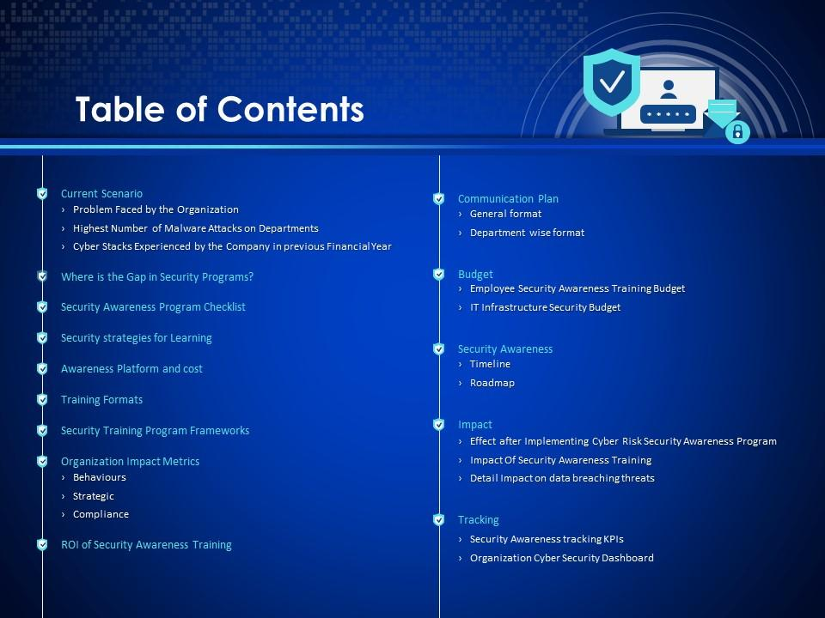

SUITABLE TECHNOLOGY
The suitable technologies used to maintain security system stronger are as follows.

Firewall:
For a system or an organization firewalls act as the first layer of security. A firewall is used to block junk files or unauthorized packets entering from the network. This can be hardware or in-built software. Though the function of a firewall is inspecting and filtering packets, setting up with suitable configurations matter. Firewall with incorrect configurations can be bypassed by changing the file pattern.

Anti-virus applications:
Malware in a system can delete or overwrite files, slow down the system, crashes the system and sometimes helps the attacker to compromise the system or servers. These include viruses, trojans, worms, ransomware, spyware and more. These malware can be detected using malware scanners popularly called anti-virus software. The function of anti-virus software is to identify, block or delete the suspected files by scanning the entire system. But there are few disadvantages which include more RAM consumption, sharing personal information and not supporting comprehensive protection [13].

Honeypots:
In the recent years honeypots are developed to as a security alarm which helps the admin or security analyst in finding the intruder. These are used to deflect the hacker to different path and prevent the information. Though using this technology attack can be prevented in the initial stage, false alarms can occur with improper configurations.

User credentials:
For computer or web application accessing entering user credentials in first step for authentication and authorization purpose. The usual way of accessing is by entering username and password which specifies uniqueness of every user. As these can be stolen by the hacker to pretend like the user. This is known as social engineering attack. This problem can be overcome with the latest solution, one time password (OTP). This is a unique password sent to the mobile or email. This is also known as 3 way authentication.

Access control lists:
Maintaining ACL(Access control list) for accessing files depending upon their sensitivity is trending with the growing cyber threats. ACL is creates a specific list of people with privileges to access files or directories or to block specific group of people. This is mostly used in organization to secure highly confidential files from insiders. List usually depends on role and criteria on the employee.

CONCLUSION
cybersecurity has endless benefits followed by few disadvantages. Even large scaled security organizations were the victims on these cyber attacks. Organizations dealing with sensitive information and having low cybersecurity knowledge like medical and banking sectors have huge risk cyber threats. Hiring a role to perform cybersecurity operations for the organization is helpful to defend cyber crimes. Including that companies has a respectability to train their employees with proper cybersecurity knowledge. This help employees to identify the attack at the initial stage which may not be helpful in defending the attack but can help in minimizing the loss. Though this indirectly trains employees to perform insider attack without any traces, this can reduced by implementing constant surveillance and security policies.

References
[1] Commissum. (12th OCT 2018). The CIA Triad: The key to Improving Your Information Security. Available: https://commissum.com/blog-articles/the-cia-triad-the-key-to-improving-your-information-security# . Last accessed 13th Nov 2020.
[2] Dakota Murphey. (27th June 2019). A history of information security. Available: https://www.ifsecglobal.com/cyber-security/a-history-of-information-security/#:~:text=Cybersecurity's%20history%20began%20with,small%20trail%20wherever%20it%20went. . Last accessed 11th Nov 2020.
[3] Cristea Lavinia Mihaela. (2020). “Current security threats in the national and international context”. Accounting and Management Information Systems. Vol. 19 (No. 1), 351-378.
[4] Federal Register. (14th July, 2010). Department of Health and Human Services . Federal Register. 75 (2), 40869-40876.
[5] Drtil, (2013) “impact of information security incidents - theory and reality”. Journal of Systems Integration. No. 1: 44-52.
[6] YUEN MEIKENG. (2020). Cybersecurity cases rise by 82.5%. Available: https://www.thestar.com.my/news/focus/2020/04/12/cybersecurity-cases-rise-by-825 . Last accessed 13th Nov 2020.
[7] PwC. (2015). Information Security Breaches Survey 2015 – Full Report. Available: https://assets.publishing.service.gov.uk/government/uploads/system/uploads/attachment_data/file/432412/bis-15-302-information_security_breaches_survey_2015-full-report.pdf . Last accessed 13th Nov 2020.
[8] BBC. (27th Oct 2020). NHS 'could have prevented' WannaCry ransomware attack. Available: https://www.bbc.co.uk/news/technology-41753022 . Last accessed 13th Nov 2020.
[9] BBC. (12th May 2017). NHS cyber-attack: GPs and hospitals hit by ransomware. Available: https://www.bbc.co.uk/news/health-39899646 . Last accessed 13th Nov 2020.
[10] Alhogail A. & Abdulrahman. (2014). “A framework of information security culture change”. Journal of Theoretical and Applied Information Technology. Vol. 64 (No. 2), 540-548.
[11] Julia Dutton. (26th September 2017). Three pillars of cyber security. Available: https://www.itgovernance.co.uk/blog/three-pillars-of-cyber-security . Last accessed 13th Nov 2020.
[12] Vidhya P.M. (February 2014). CYBER SECURITY -Trends and Challenges. International Journal of Computer Science and Mobile Computing. 3 (2), 586–590.
[13] Josh Giesing. (7th April, 2017). 7 Disadvantages Of A Free Antivirus Program. Available: https://www.cprou.com/software/7-disadvantages-of-a-free-antivirus-program/. Last accessed 11th Dec 2020.

